Reconnaissance Practice

Name: Vijayashree B
Domain: Cybersecurity (VAPT)
Date of Submission: 20.03.26

- Reconnaissance Practice:
  - Tools Used:
- Maltego
- Shodan
- WHOIS
  - Domain Info:
Website using for Reconnaissance: (example.com)
WHOIS website:
Info obtained:
- Registrar: RESERVED-Internet Assigned Numbers Authority
- IANA ID: 376
- Name Servers:
  - elliott.ns.cloudflare.com
  - hera.ns.cloudflare.com
Wappalyzer:
Info obtained: (Technologies used)
- Miscellaneous: HTTP/2
- CDN: Cloudflare
  - Subdomain Info:
Using the crt.sh certificate transparency logs, multiple certificate entries were identified for the target domain example.com.
Findings:
- Certificates issued for:
  - example.com
  - *.example.com (wildcard subdomain)
- Presence of wildcard (*.example.com) indicates:
  - The domain supports multiple subdomains
  - Subdomains may exist even if not directly listed
Certificate Details Observed
- Issuers:
  - Sectigo Limited
  - DigiCert
  - Cloudflare Inc
- Certificate Types:
  - Public Server Authentication Certificates
- Validity Period:
  - Certificates issued across multiple dates (2025–2026)
Analysis
- The domain uses trusted Certificate Authorities (Sectigo, DigiCert, Cloudflare)
- Use of wildcard certificates suggests:
  - Scalable infrastructure
  - Possible multiple subdomains (not all publicly visible).

  - Exposed Services:
Using Shodan, multiple hosts and services associated with the target were identified.
Findings
- Total results: 254,295+ devices/services
- Multiple IP addresses observed from different locations worldwide
- Common countries:
  - United States
  - China
  - Germany
  - United Kingdom
  - Singapore
Sample Exposed Hosts
1. Host: 51.222.130.110
- Organization: OVH Hosting Inc.
- Location: Canada
- Service: HTTP
- Server: Apache/2.4.48 (Unix)
- Status: 200 OK
2. Host: 47.108.175.77
- Organization: Aliyun Computing Co., LTD
- Location: China
- Service: Web interface
- Observation: Marked as honeypot
- Note: Connection not secure
3. Host: 172.104.252.63
- Organization: Linode
- Location: Germany
- Service: Web Client
- Tags: Cloud, Honeypot
4. Host: 103.14.130.140
- Organization: Radiant Gazipur Zone Retail Network
- Location: Bangladesh
- Service: SSL Certificate
- Observation: Self-signed certificate
Common Open Ports
- Port 80 → HTTP
- Port 443 → HTTPS
- Other ports also observed across devices
Technologies Identified
- Apache HTTP Server
- Embedded web servers (e.g., httpd)
- Network devices (routers, firewalls)
- Cloud-hosted systems
Security Observations
- Presence of honeypots (fake systems for monitoring attacks)
- Some services using self-signed SSL certificates
- Multiple globally distributed systems increase attack surface
  - Asset Mapping:
Using Maltego, the target domain was analyzed to identify its associated infrastructure and relationships.
Findings:
- The domain example.com was successfully resolved to its corresponding IP address.
- DNS analysis revealed associated records including name servers (NS) and domain mappings.
- Limited subdomains were identified, indicating a minimal publicly exposed structure.
Infrastructure Insights:
- The domain is linked to a centralized hosting environment.
- IP resolution provided information about the hosting network and geographical location.
- The relationships between domain, DNS records, and IP address were visualized using Maltego’s graph interface.
Analysis:
- The graph-based mapping helped in understanding how the domain connects to its infrastructure components.
- No complex or large-scale network structure was observed, suggesting a simple configuration.
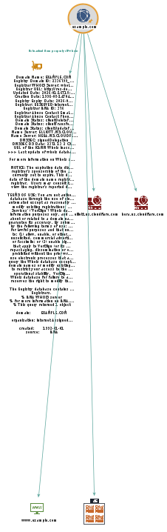

Asset Mapping log:

Timestamp | Tool | Finding
2026-03-19 10:00:00 | WHOIS | Collected domain registration details
2026-03-19 10:15:00 | crt.sh | Identified certificate entries and wildcard subdomains
2026-03-19 10:30:00 | Sublist3r | Identified subdomain: www.example.com
2026-03-19 10:45:00 | Shodan | Detected open ports 80 (HTTP) and 443 (HTTPS)
2026-03-19 11:00:00 | Maltego | Mapped DNS records and IP address
2026-03-19 11:15:00 | Wappalyzer | Identified basic web technology stack

Summary:
Reconnaissance identified domain details, subdomains, and exposed services using OSINT tools. WHOIS provided registration data, crt.sh and Sublist3r revealed subdomains, and Shodan detected open ports. Maltego mapped domain relationships and infrastructure. The findings highlight the target’s structure and potential attack surface for further security assessment.

